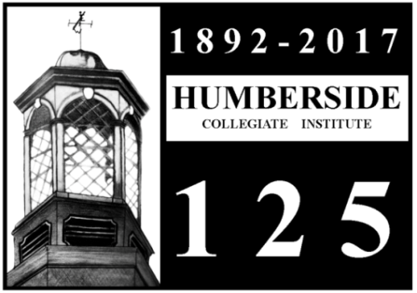
Gala Countdown to the 125th
Friday October 23, 2015
7pm – 10pm
At Humberside Collegiate Institute

Join the current Humberside community, alumni, staff and friends for an evening of wine & cheese, camaraderie and memories as we kickoff the celebrations leading up to Humberside’s 125th Anniversary in 2017.
See the partially refurbished auditorium seats in Lismer Hall to which many of you have so generously donated. Enjoy the recently unveiled murals in the front foyer depicting the history of our school in the community. Help support the ongoing fundraising efforts held during the evening to complete the rejuvenation of Lismer Hall, where the historic mural by Arthur Lismer, created specifically for Humberside, is on display.
Your support helps honour the history of Humberside
Purchase a seat and become a visible, permanent part of that history.

Tickets $25 eachCash Bar
Tickets available via PayPal on the Humberside Alumni website
Click on the following link http://www.hcialumni.org/?p=295
(you don’t need to be a member of PayPal to order tickets)
Or use the form below and mail in your cheque.
You can also call and leave a message with a contact number at 416-393-8122 x 20125 or
emailhumberside125@gmail.com with any questions.
Visit the Alumni Website for more information about the Auditorium seats and how to purchase one.
For further information and to be kept up to date about all events,
be sure to join the alumni association atwww.hcialumni.org
Join us on facebook at https://www.facebook.com/groups/219791771544317/
Link to purchase seatshttp://www.canadahelps.org/CharityProfilePage.aspx?CharityID=S19211
Name:__________________________________________________ Number of Tickets at $25 each:______
Address:_________________________________________________________________________
Email:_____________________________________ Phone Number:_________________________
Mail form and cheque (payable to HCI Alumni) to
HCI 125 Gala
280 Quebec Ave., Toronto, ON
M6P 2V3

